ICIC Express Letters ICIC International ⓒ2010 ISSN 1881-803X
Volume 4, Number 5, October 2010 pp. 1–6

IndoBERT for Multi-Level Stress Classification Through the Lens of Interpretability: Assessing Explanation Fidelity and Stability with SHAP and Integrated Gradients

Indrawan Wijaya and Maria Susan Anggreainy
Computer Science Department, BINUS Graduate Program – Master of Computer Science
Bina Nusantara University
Jl. Raya Kb. Jeruk No.27, Kemanggisan, Palmerah, Jakarta 11530, Indonesia
indrawan.wijaya@binus.ac.id; maria.anggreainy@binus.edu

Received February 2010; accepted April 2010

Abstract. BERT-based models such as IndoBERT have become the standard for Indonesian-language text classification, yet research around them concentrates heavily on predictive performance while giving little attention to interpretability. This study addresses that gap by fine-tuning IndoBERT for multi-level stress classification of student forum posts, labelled as no stress, mild stress, or severe stress, and by evaluating the interpretability of its predictions. Class imbalance in the dataset is handled using a weighted random sampler during training. The fine-tuned model reaches a testing accuracy of 0.9942, precision of 0.9218, recall of 0.9624, and F1-score of 0.9412, with every class exceeding a 90% per-class success rate. Two explainable AI methods, SHAP and Integrated Gradients (IG), are then applied to explain the predictions, and their explanations are assessed on two dimensions: fidelity, measured through an infidelity score, and stability, measured through cosine similarity under synonym-substitution perturbation. SHAP achieves a lower infidelity score (0.0340 against 0.0406 for IG), indicating more faithful explanations, whereas IG attains slightly higher stability (0.3536 against 0.3453). The results show that both methods produce reasonably faithful explanations of the model's decisions but remain sensitive to lexical variation, which limits the robustness of their interpretability under input perturbation.
Keywords: Please write down the keywords of your paper here, such as, Intelligent information, System control

1. Introduction. The past few years have undergone a tremendous advancement in artificial intelligence, especially deep learning, with new models continuously emerging and pushing the boundary of state-of-the-art (SOTA) performance [1]. In practical applications like sentiment classification, where models are used to automatically identify the emotional tone or opinion stated inside a text, this advancement is particularly prominent [2]. In the midst of all these advancements, a model known as BERT appeared. It later developed and gained recognition for its exceptional performance, serving as the basis for most numerous text classification tasks as of today.
BERT (Bidirectional Encoder Representations from Transformers) is a language model built on the transformer architecture. Contrary to processing text in a single direction as some earlier models did, it simultaneously draws attention to both preceding and succeeding words to develop contextual representations of the text [3]. In addition to establishing BERT as a fundamental baseline for text-related deep learning research, this bidirectional method allowed for significant advances across a variety of natural language processing (NLP) applications [4], [5]. Since then, several derivative models designed to meet more specialized requirements have been inspired by its success, including DistilBERT for efficiency [6], XLM-RoBERTa for cross-lingual jobs [7], and IndoBERT for the Indonesian language [8]. As these BERT-based models have develop, a glaring bias has emerged in the studies around them. Most efforts concentrate on improving performance metrics such as accuracy, F1-score, and other standard evaluation benchmarks, while relatively little attention is given to a different but equally important dimension: interpretability, or the extent to which a model's predictions can be understood and trusted by the people who rely on them [9], [10], [11], [12]. This is a critical flaw, because sentiment classification models are eventually deployed to assist human users, whether in business, research, or public-facing applications. Research study [13] revealed that model transparency is crucial for a black-box system in order to build user trust in the predictive decisions it provides.
Bridging this gap requires a way to observe what a model such as IndoBERT is doing when it makes a prediction. This is where explainable AI (XAI) methods become necessary. This research makes use of SHAP (SHapley Additive exPlanations) and Integrated Gradients (IG), two widely used XAI techniques that produce explanations by assessing the contribution of each input feature to a model's prediction [14], [15]. These methods make it possible to inspect a model's decision-making process rather than treating it purely as a black box. However, generating an explanation is only half of the problem. The explanation itself needs to be assessed to see if it is reliable and trustworthy, which raises the discussion of how interpretability itself should be measured.
Since interpretability is harder to pin down than performance. Where predictive performance is commonly assessed through standardized metrics such as accuracy, precision, recall, and F1-score, while interpretability lacks an equivalent, universally agreed-upon evaluation framework [16], [17], [18]. Numerous metrics have been proposed in the literature instead, including faithfulness, comprehensiveness, and robustness, each capturing a different facet of what it means for a model's explanation to be "interpretable" [19] . Given this diversity, no single metric can be considered a complete or definitive measure of interpretability, which means any research in this space must first define its own scope. This research focuses specifically on fidelity and stability, two dimensions commonly discussed in the interpretability literature [20], [21]. Fidelity concerns whether an explanation faithfully reflects the model's internal decision-making process, while stability concerns whether that explanation remains consistent under small perturbations to the input.
This performance-interpretability gap is quite noticeable for IndoBERT. Despite being widely adopted as the leading BERT-based model for Indonesian-language sentiment classification, IndoBERT has not been thoroughly evaluated from an interpretability standpoint [9], [10], [22], [23]. Most existing work on IndoBERT has centered on benchmarking its predictive accuracy against other models, leaving open the question of how well its predictions can be understood by the people who use them. We use fidelity and stability as the main evaluation metrics to assess how well SHAP and IG can explain IndoBERT's predictions in sentiment classification, treating this as our operational measure of the model's interpretability in this work. In this regard, the study endeavors to highlight how effectively existing SOTA models can be understood through XAI-based explanations, as opposed to simply predicting accuracy. This research makes two contributions. First, it provides an empirical interpretability evaluation of a popular Indonesian NLP model that has previously been assessed mostly based on performance. Second, it aims to inform more interpretability-conscious development and evaluation practices for BERT-based models moving forward.

2. Methodology. An overview of the research methodology is clearly illustrated in Figure 1. This research began with a systematic literature review to gain an understanding of the current state of research in the same field, so that gaps or topics that have not yet been extensively explored could be identified. After identifying the gaps, research questions were formulated and became the focus of the research, followed by data collection for the development of the IndoBERT model. The data for this research will be obtained from previously conducted research, a dataset consisting of text posts from a student venting forum on an online platform belonging to a university community. This dataset will be labeled with stress level indicators for each student based on the text of their posts, with level zero indicating no stress, level one indicating mild stress, and level two indicating severe stress.
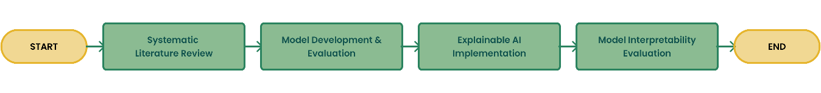
Figure 1. The general approach carried out in this research.
The data collected contain noises in the form of mentions or excessive characters that will be irrelevant to the model training process; therefore, a data “cleaning” process is necessary, which is commonly known as the preprocessing stage. This data cleaning process will include several steps, ranging from removing duplicates, removing unique or excessive characters, removing mentions of usernames or forum names, removing excessive whitespace, and converting all characters to lowercase (case folding). Once all the data has been cleaned, the process will proceed to the IndoBERT deep learning model development phase. This phase begins by dividing the data into three parts in an 80:10:10 ratio, where 80% is training data, 10% is validation data, and the remaining 10% is testing data. If an imbalance between classes is detected in the data, the WeightedRandomSampler, a PyTorch library tool, will be applied. This tool samples elements from the dataset with specific probabilities based on the weights assigned to each data point, addressing the imbalance by oversampling the minority class and/or undersampling the majority class.
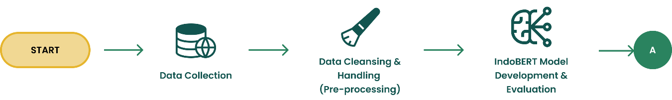
Figure 2. IndoBERT Fine-tuning development and evaluation stage.
The process of fine-tuning the model will then make use of the cleaned and processed data. The "indobert-base-p2" variation from Indo4B will serve as the base model for this research [24]. To produce a classification prediction based on three label categories, whether the text indicates no stress, mild stress, or severe stress, a classification head will be incorporated as part of the model architecture fine-tuning process. During the model's development, several hyperparameter configurations were utilized to get the best outcomes. A learning rate of 1e-5, a batch size of 16, 10 epochs with an early halting mechanism if no progress is seen, and optimization using AdamW are some of the hyperparameters applied throughout the development phase. After the fine-tuning process was completed, the next step was to evaluate the model’s performance. The performance of the fine-tuned IndoBERT model was assessed based on standard metrics in machine learning: accuracy, precision, recall, and F1-score. The evaluation was conducted to ensure that the predictive performance of the resulting fine-tuned model was satisfactory before proceeding to the interpretability analysis phase.
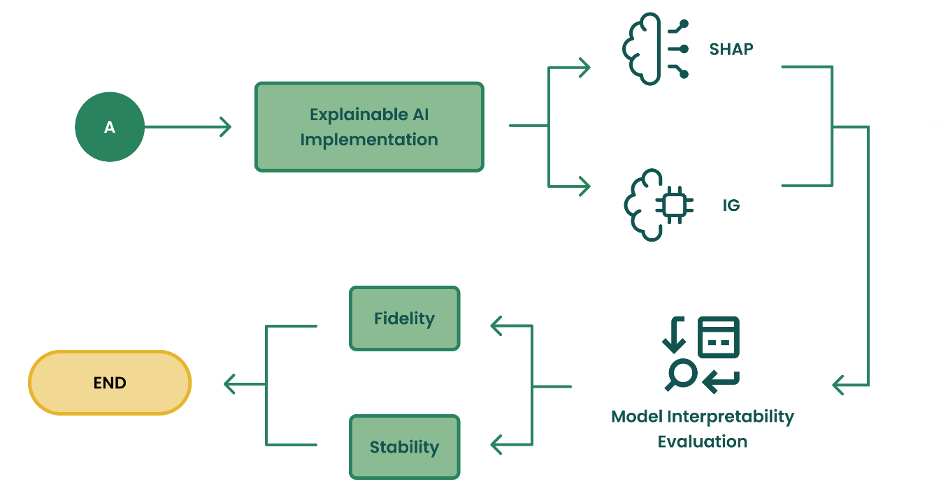
Figure 3. Model development and interpretability evaluation stage using XAI, evaluated through fidelity and stability.
Following the successful development of the fine-tuned IndoBERT model, the following stage of this research focused on applying XAI approaches to produce explanations for the model's predictions. Specifically, this research applies SHAP and IG to the fine-tuned model. SHAP is applied using the shap Python library within this research. The fine-tuned IndoBERT model is first wrapped in a HuggingFace text-classification pipeline, which returns prediction probabilities for all three stress-level classes. A SHAP explainer is then constructed using this pipeline, paired with a text masker (shap.maskers.Text) built from the model's own tokenizer, allowing SHAP to perturb the input text at the token level in a manner consistent with how the model itself processes text. For each test sample, the model's predicted label is first obtained, and SHAP values are computed specifically with respect to that predicted class. This yields a SHAP value for each sub word token in the input, representing its estimated contribution to the model's prediction. Since IndoBERT's tokenizer splits words into sub word units, SHAP values belonging to tokens originating from the same word are subsequently summed, producing a single attribution score per word rather than per sub word. This reconstruction step ensures that the resulting explanations remain interpretable at a linguistically meaningful level rather than being fragmented across sub word pieces.
In addition to SHAP, this research IG as a second explanation method, implemented using the Captum library. IG is computed with respect to the model's input embeddings, using a baseline defined as the sequence of embeddings corresponding to the tokenizer's padding token. Attributions are computed with respect to the model's predicted class, using 20 integration steps, and are calculated at the embedding dimension before being summed to obtain a single attribution score per token. The resulting token-level scores are then normalized using their L2 norm to standardize the scale of attributions across samples. As with SHAP, the resulting sub word-level attributions are merged into word-level scores by summed the attributions of sub word tokens belonging to the same word, ensuring consistency between the two explanation methods in how attributions are ultimately reported. All the process is repeated across all samples in the test set, and the resulting attributions, along with their corresponding scores, predicted labels, and sample identifiers, are compiled into a structured dataset for subsequent interpretability evaluation.
With the word-level attributions from both SHAP and IG compiled for all test samples, the next step is to evaluate how faithfully these attributions reflect the model's actual decision-making process. This is assessed using the faithfulness (infidelity) formula as in:
${\text{E}}_{\text{I}}\left[{\left({\text{Ι}}^{\text{T}}\text{Φ}\left(\text{x}\right)\text{ - }\left(\text{f}\left(\text{x}\right) \text{- }\text{f}\left(\text{x}\text{ - Ι}\right)\right)\right)}^{\text{2}}\right]$ (1)
Where $\text{Φ}\left(\text{x}\right)$ denotes the attribution score computed for each input text $\text{x}$ in the test set using the interpretability method being evaluated, representing the estimated contribution of each token toward the model's prediction, and $\text{I}$ represent a perturbation mask indicating which tokens are masked from the input. While the original formulation of this metric defines $\text{I}$ as a random perturbation sampled from a distribution of possible masks, this research adopts a targeted variant in which $\text{I}$ is deterministically constructed from the top-k tokens identified as most influential by the explanation method for each input. This approach directly tests the specific claim made by each explanation, namely that its top-ranked tokens are the ones most responsible for the model's prediction. Masking these top-k tokens gives a new input, denoted $\text{x - I}$. The model is then run on this perturbed input to obtain $\text{f}\left(\text{x - I}\right)$ and measure the actual change in output as $\text{f}\left(\text{x}\right) - \text{f(x - I)}$. The change predicted by the attribution scores is ${\text{I}}^{\text{T}}\text{Φ(x)}$, the sum of the attribution scores of the masked tokens. For each input, the squared error between the actual and predicted change is computed, then averaged over the test set to give an overall infidelity score for each explanation method. The lower the infidelity, the more closely the attributions track each token's true influence on the prediction, meaning the explanation is more faithful.
Besides faithfulness, the stability of each explanation method is also evaluated, that is, whether its attributions stay consistent when the input is only slightly changed. This is measured using the formula (2).
$\frac{\text{1}}{\text{N}} \sum_{\text{i=1}}^{\text{N}}{{\text{cos}}_{\text{sim}}}\text{(}{{\text{x}}_{\text{1}}}^{\left(\text{i}\right)}\text{, }{{\text{x}}_{\text{2}}}^{\text{(i)}}\text{)}$ (2)
Here, ${{\text{x}}_{\text{1}}}^{\left(\text{i}\right)}$​ is the explanation for the original, unperturbed input and and ${{\text{x}}_{\text{2}}}^{\text{(}\text{i}\text{)}}$ is the explanation for a perturbed version of that same input, across all $\text{N}$ test samples. The perturbed input is built through synonym replacement, swapping selected words for equivalent single-word synonyms taken from the Indonesian thesaurus dataset compiled from Tesaurus Bahasa Indonesia Pusat Bahasa (victoriasovereigne/tesaurus). Because this thesaurus maps each word to a single-word synonym rather than a multi-word phrase, the perturbed input keeps the same token count and structure as the original, so the two explanation vectors ${{\text{x}}_{\text{1}}}^{\left(\text{i}\right)}$​ and ${{\text{x}}_{\text{2}}}^{\text{(i)}}$ ​stay directly comparable. The cosine similarity between them is then taken to gauge how well the explanation holds up under a semantically equivalent change. A higher average cosine similarity over the $\text{N}$ samples means greater stability: the method gives consistent attributions even when the wording shifts slightly.

3. Result and Discussion. The dataset was obtained from IndrawanW02/IndoBERT-Through-the-Lens-of-Interpretability, which included 31,882 tagged raw data sets of student forum messages. The data breakdown is displayed in Fig. 4. The total number of data points was decreased to 30,953 after duplicates were discarded. 28,458 data with the label 0 (no indication of stress), 1,848 data with the label 1 (indication of mild stress), and 648 data with the label 2 (indication of severe stress) make up the data. The WeightedRandomSampler package was used in this work to make sure that the model construction was not skewed toward the majority class after it was determined from the details of the gathered data that the dataset was unbalanced.
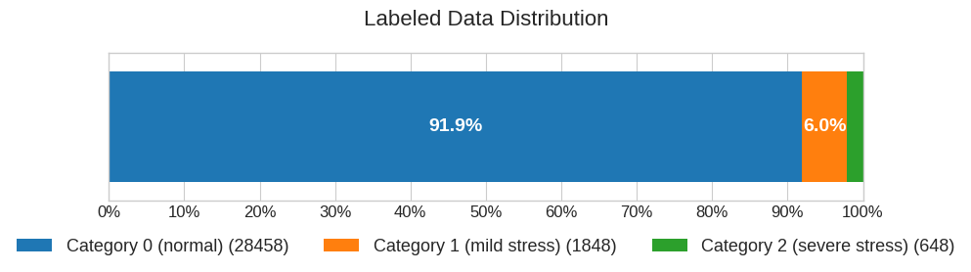
Figure 4. Data Distribution Ratio.
Following that, the data was cleaned as previously mentioned, which included eliminating unnecessary characters and excessive whitespace, among other things. A stratified split with an 80:10:10 ratio is then used to partition the cleaned data, yielding 24,444 data for the training set, 3,056 data for the validation set, and 3,056 data for the testing set.
The research moved on to the model construction and performance evaluation phase once all the data was prepared for additional processing. To achieve the best model outcomes, the model was developed through a fine-tuning procedure using the hyperparameter settings previously discussed in Chapter II. The outcomes of the training and validation procedures are displayed in Figure 5, where the graph displays both little overfitting and steady development. The training and validation results differ very little, as both graphs demonstrate. This is seen in the validation loss over epochs where the difference is only within a range of 0.05, and validation accuracy over epochs which displays even smaller deviations, with a difference of just 0.02. After completing the training and validation phases, the model moved on to the testing phase to measure its real performance. The model's performance details are displayed in the testing results as follows: 0.9942 accuracy, 0.9218 precision, 0.9624 recall, and 0.9412 F1-score.
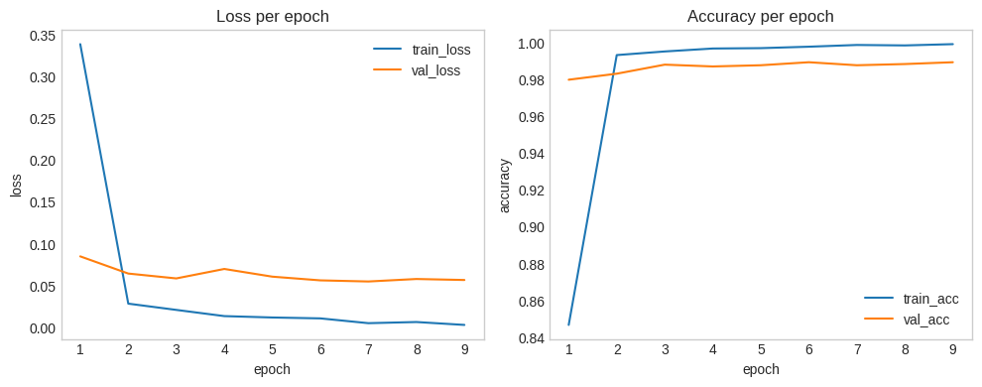
Figure 5. Fine-Tuned IndoBERT model's learning curves, which include training and validation loss over epochs and training and validation accuracy over epochs.
Overall, these results indicate that the model performed well, since every metric was close to 1. The testing phase also produced a confusion matrix, shown as a heat map in Figure 6., to examine the predictions more closely. Some false positives and false negatives appear in every class, so the multi-label classification is not yet fully optimal. Even so, misclassified samples make up only a small fraction of the total. The per-class results remain satisfactory despite this: Class 0 reaches a prediction success rate of 99.28% and Class 1 reaches 97.25%. Class 2, the minority class, still attains 92.18%.
All three classes exceed a 90% success rate, which suggests the model does not lean only on the dominant classes for its high overall scores. It has instead learned discriminative patterns that generalize across every class, including the minority class that is usually hardest to predict under class imbalance. The remaining errors are not negligible, but they stay small and are spread thinly across the classes rather than piling up in one, which points to no severe bias toward any single label. The roughly 7% gap between Class 0 and Class 2 does mark the minority class as the weakest point, consistent with its limited number of training samples. In practical terms, the model is reliable enough for the classification task while still leaving room for improvement
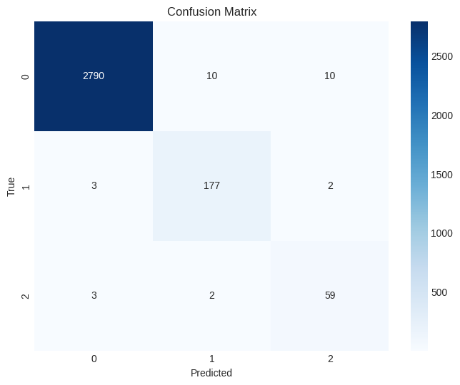
Figure 6. Confusion Matrix representing Fine-Tuned IndoBERT model classification performance.
With the model confirmed to perform satisfactorily, the research moved on to the interpretability evaluation. Two XAI methods, SHAP and IG, were applied to explain the model's predictions, and the resulting word-level visualizations for each class appear in Figure 7.
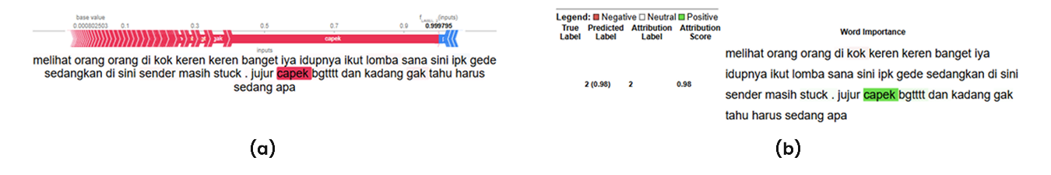
Figure 7. Word attribution visualizations example for the predicted classes using
(a) SHAP and (b) IG.
In both methods, each word is colored based on its attribution value, which reflects how much that word contributes to the predicted label, with color intensity showing the magnitude of the contribution. In the SHAP visualization, red marks words with positive attribution that push the model toward the predicted label, while blue marks words with negative attribution that push it away. IG follows a different color scheme: green marks words with positive attribution that support the predicted label, and red marks words with negative attribution that counter it.
To assess interpretability in terms of fidelity and stability, both XAI models are applied to the complete test dataset. As noted earlier, fidelity is evaluated through the resulting fidelity error (infidelity). Table I reports the interpretability findings for the optimized IndoBERT model.
Table 1. Interpretability Measurement Results
XAI Model | Infidelity | Stability
SHAP | 0,0340 | 0,3453
IG | 0,0406 | 0,3536
The infidelity metric shows how well the attribution values match the model's actual decision process, where a value closer to 0 means a more faithful explanation. The stability metric measures how consistent the explanations are when the input is given small changes, where a higher value means a more stable and reliable explanation. As shown in Table I, SHAP achieved an infidelity score of 0.0340, which is better than IG’s 0.0406, indicating that SHAP produces explanations that better represent the true predictive behavior of the model. However, for stability the opposite trend is observed, where IG scored 0.3536 compared to 0.3453 for SHAP, indicating that IG explanations are more stable than SHAP explanations when considering small input variations. When examined via the lens of the XAI models SHAP and IG, the IndoBERT model's overall performance produces findings that are satisfactory in terms of faithfulness but extremely worrying in terms of stability. In terms of fidelity, this means that the explanations given fairly depict how the model produces interpretability that is in line with the refined model. As for why the stability results are less than satisfactory, it is most likely due to the stability evaluation's perturbation method, which substitutes synonyms for words. The deep learning model will effectively return to a state of total ignorance about that term if it hasn't yet "learned" those synonyms.

4. Conclusions. The findings of this research show that the fine-tuned IndoBERT model achieved strong classification performance, with a testing accuracy of 0.9942, precision of 0.9218, recall of 0.9624, and F1-score of 0.9412. Per-class results further indicate that the model handled the minority class reasonably well, achieving a success rate of 92.18%, even though it remained the weakest-performing class compared to Class 0 (99.28%) and Class 1 (97.25%). Beyond predictive performance, this research also evaluated the interpretability of the model's predictions through SHAP and IG, using fidelity and stability as the evaluation metrics. The results show that both methods produced explanations that fairly depict how the model arrives at its predictions, as reflected in the satisfactory infidelity scores of 0.0340 for SHAP and 0.0406 for IG. However, the stability results were far less satisfactory, with scores of 0.3453 for SHAP and 0.3536 for IG. This is most likely caused by the synonym-substitution perturbation method used in the stability evaluation, since the model tends to respond poorly to synonyms it has not encountered during fine-tuning, effectively treating them as unfamiliar terms. In conclusion, the fine-tuned IndoBERT model can produce faithful and interpretable explanations of its predictions, but its explanations remain sensitive to lexical variation, which limits the robustness of its interpretability under input perturbation. It is also worth noting that these fidelity and stability results are specific to SHAP and IG as applied to this fine-tuned IndoBERT model, rather than general properties of either the model or the XAI methods in isolation.
Although this research has achieved satisfactory results in both classification performance and interpretability evaluation, several key limitations remain that could be the focus of future development. The main limitation is the class imbalance in the dataset, which shows up as a lower prediction success rate for the minority class. This suggests the model might still be a bit biased toward the majority classes, which could affect how reliable its predictions are in real-world settings where the data is imbalanced. Because of this, more research is needed to deal with the imbalance, for example through more balanced data collection or better data augmentation, so the model can generalize more evenly across all classes. A second limitation is the fairly low stability scores, which are probably caused by the synonym-substitution method used in the evaluation, since the model tends to do poorly with synonyms it did not see during fine-tuning. So future work can try other perturbation methods, such as paraphrasing, back-translation, or character-level noise, to find out whether this instability only happens with synonym substitution or is a more general property of the model's explanations. Future work can also try other XAI methods besides SHAP and IG, or other interpretability metrics besides fidelity and stability, to get a fuller understanding of how well IndoBERT's predictions can be explained and trusted by end users.

Authors Contributions. I.W. commenced the research design, reviewed the literature, preprocessed the data, developed the model and conducted the experiments, evaluated the findings, and wrote the report. M.S.A. oversaw the research process, helped with data collecting and collaboration with the psychology team, gave the study its original conceptual direction, and critically examined, revised, and proofread the article. The final document has been read and approved by both authors, who are also accountable for its integrity and substance

Acknowledgment. The authors would like to sincerely thank Dr. Pingkan C. B. R. and her team for helping to validate the data labels in the earlier study, which was a crucial source of information for this study's validation procedure.

REFERENCES

- M. Mahmoud and P. Shi, Methodologies for Control of Jump Time-delay Systems, Kluwer Academic Publishers, Boston, 2003.
- P. Shi, Limited Hamilton-Jacobi-Isaacs equations for singularly perturbed zero-sum dynamic (discrete time) games, SIAM J. Control and Optimization, vol.41, no.3, pp.826-850, 2002.
- S. K. Nguang and P. Shi, Fuzzy H-infinity output feedback control of nonlinear systems under sampled measurements, Automatica, vol.39, no.12, pp.2169-2174, 2003.
- E. K. Boukas, Z. Liu and P. Shi, Delay-dependent stability and output feedback stabilization of Markov jump systems with time-delay, IEE-Part D, Control Theory and Applications, vol.149, no.5, pp.379-386, 2002.
- P. Shi, E. K. Boukas and R. K. Agarwal, H1 control of discrete-time linear uncertain systems with delayed-state, Proc. of 37th IEEE Conference on Decision & Control, Tampa, Florida, pp.4551-4552, 1998.

